Minutes for Meeting 1:

Pre-Planned Agenda

* Set Foundation
* Roles
* Expectations
* Schedules
* Intro to the Whole Picture

|  |  |  |  |
| --- | --- | --- | --- |
| S/N | Agenda (In details) | Brief Details: | Action By: |
| 1 | Time or Feature Boxing | Time Boxing: Every 2 Weeks | All |
| 2 | Role Management | Swap every 2 weeks | All |
| 3 | Important Dates | Refer to chart below  Try out the first 2 weeks. | All |
| 4 | Important Items | Refer to chart below | PM of the week |
| 5 | Decision on Pairs | Refer to section below (and point 2). Swap every 2 weeks. | PM of the week |
| 6 | Key Users of the Program | Students, IITS, Refer to use case picture below. | All |
| 7 | Ordering of Project | Refer to the details presented below. | All |
| 8 | Logical Diagram of Data | Refer to the diagram below. | All |
| 9 | Domain Diagram | Refer to the diagram below. | All |
| 10 | Clarifications | Clarify with Prof about Use Case Diagram | Jeremy |
| 11 | Things to do next week | Diagrams: Domain, SSD, SD, Class  Function: BootStrap – Book place with TV to program together. | All (SD Pair specific) |

3. IMPORTANT DATES

|  |  |  |
| --- | --- | --- |
| Weeks: | Important Matters | Project Manager |
| 2 | Planning (Diagrams) – Use Case, Domain | Jeremy |
| 3 | Planning (Diagrams) |
| 4 |  | Zhi Hui |
| 5 |  |
| 6 |  | Nabilah |
| 7 | PM Review |
| 8 | -Break Week- | Darren |
| 9 |  |
| 10 |  | Shu Wen |
| 11 |  |
| 12 | UAT | Jeremy |
| 13 | Sunday (End): Submission of SE Project |

Decide on iteration. Every pair will take care of each section.

Deciding on General Planning, then sub-planning with each time-boxing.

4. IMPORTANT ITEMS:

Rotation Plan

Roles

PPLog: Pair Programming Log

Checklist for the documents required

5. PAIR DECISION

Pair 1 – Darren and Shu Wen

Pair 2 – Nabilah and Zhi Hui

Project Manager: Jeremy

6. USE CASE OF KEY USERS

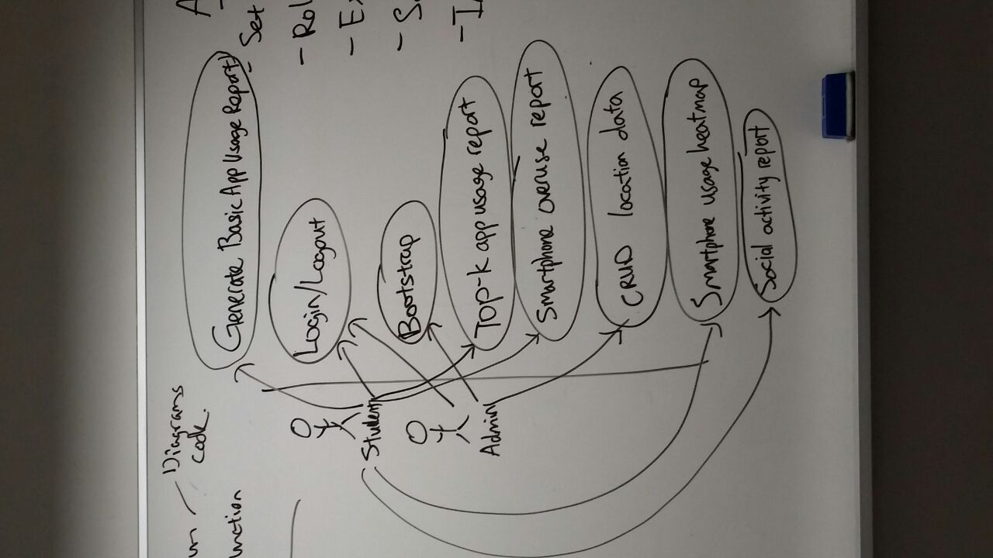

7. ORDERING OF PROJECT

Database 🡪 Entity/DAO 🡪 Control 🡪 Menu (HTML, view.jsp and do.jsp)

(JDBC)

Loading from csv – therefore can load from memory without using DB.

Csv loading will be done every time a new csv is presented, and wipes out the old database.

8. LOGICAL DIAGRAM

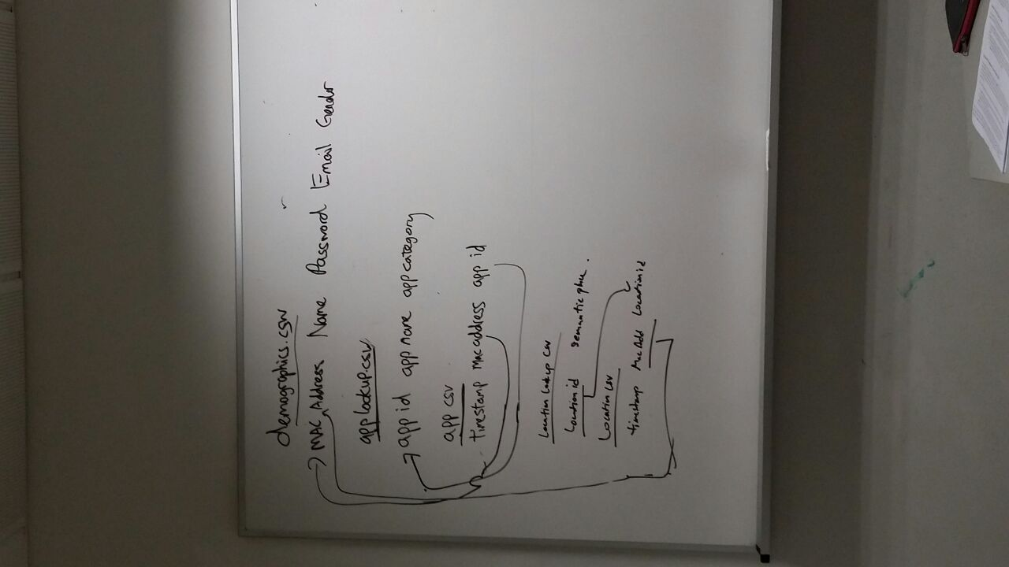

9. DOMAIN DIAGRAM

